PRACTICAL 1
Practical 1: Project Initiation, Requirement Analysis, Sitemap, Wireframe, and GitHub Setup
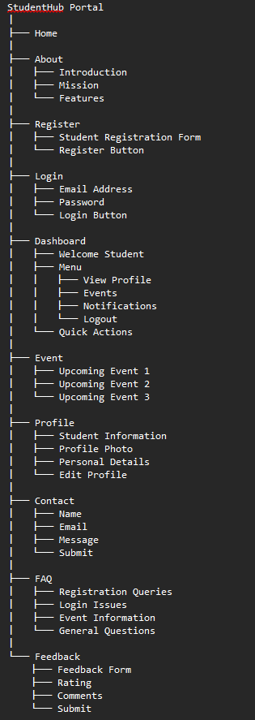
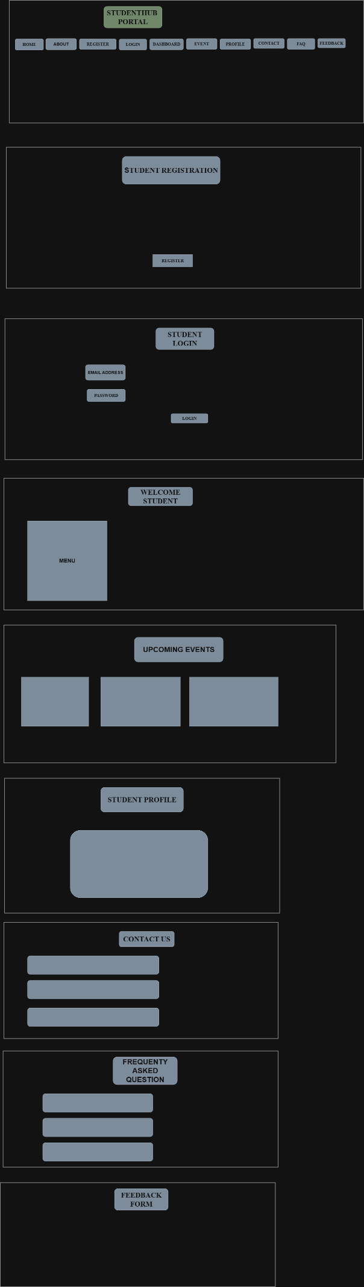
PROBELEM : in this practical I faced problem like for wireframe I cant properly draw on draw.io website
LEARNING OUTCOME : I understand the structure of my project , using wireframe and sitemap I can predict my next step .

